Lab 1 – Starting with Unity



2026/2027
UC: Desenvolvimento de Videojogos
Marcos Costa
Dinis Teixeira
Setúbal,
ESTSetúbal

Index
Game Object Components: 2
Renderer: 3

Level 1 – Brief Explanation of Game Objects
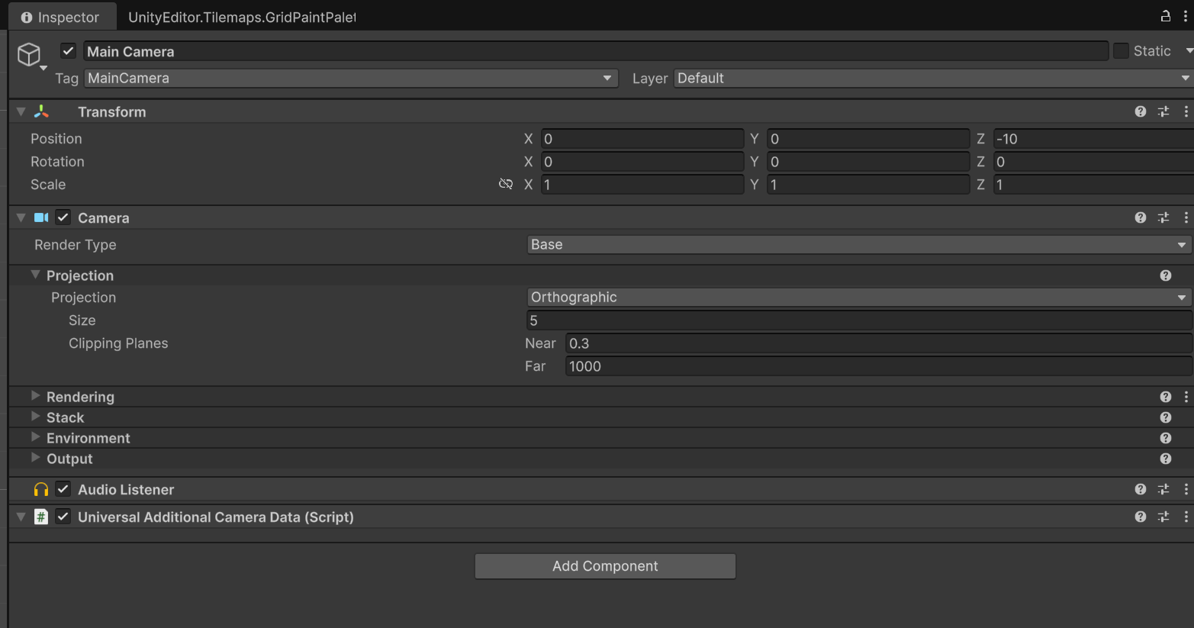
This is a screenshot of the unity inspector; it will show us the components that, in this case, belong to the Main Camera object. Allowing us to essentially modify it by altering the components already added.

We could also remove said components or add new ones.

Game Object Components:
A game object by default usually has the following components: Transform, Sprite Render (In this case because we’re in 2D), colliders and a rigidbody.

Explaining these components in more depth:

Transform:
Here we can see that the Transform component lets us change the physical aspects of the object we have selected, the position, rotation, and scale.
These are important for modifying an object as we need, for example, if you’re creating a game map where the game takes place, you will need, most of the time, to change the objects position in the XYZ axis.
The X axis is used to make the object go left or right, rotate it or change its scale in those directions.
The Y axis is used to make the object go up or down, while rotating it will spin it in either direction making the object appear thinner, and changing its scale will make the object become taller or smaller.
The Z axis in 2D will make the object appear like it is behind another object, rotating it will make it go left or right, and the scale does nothing of note.

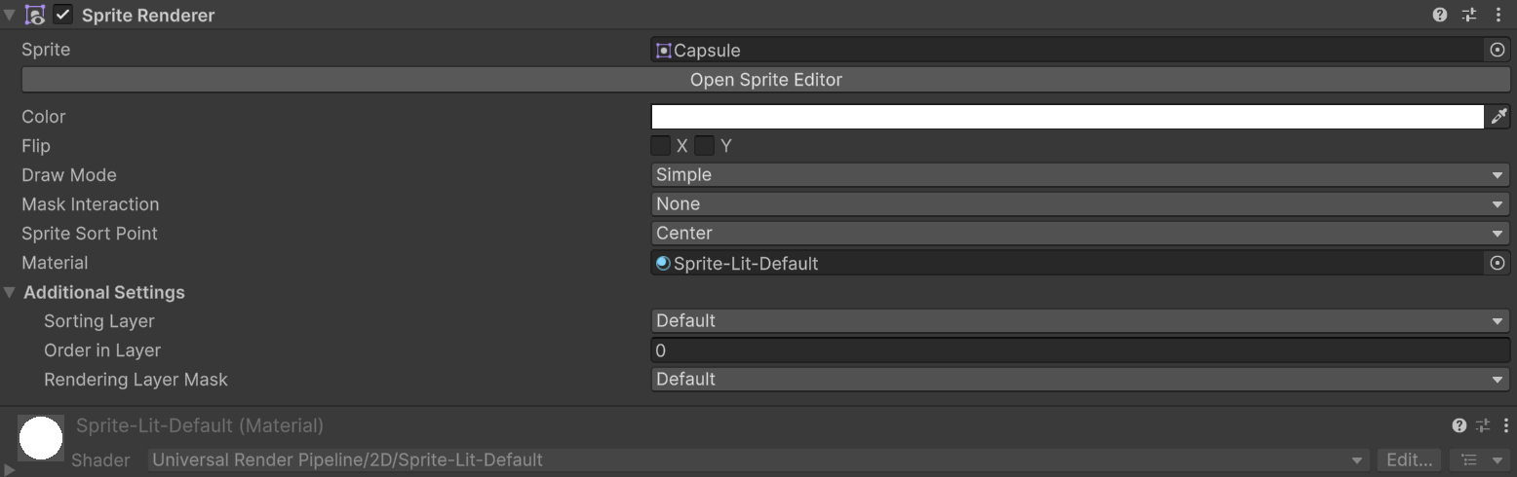
Renderer:

We can see here that this is the renderer that usually goes to objects to render how they will look, being able to flip the sprite in the X or Y axis, being able to change its material, color and other additional settings.

Level 2 – Creating a Collectible
Here we can see a floating coin on top of a lake.
This coin was created as an item that player can collect, therefore calling it a “Collectible”
Here inside the game object we can see that it contains a scirpt, the renderer that was talked about earlier and a collider.

Script:
This script here that is labeled as “Collectible” will check if the collider with the “Player” tag has triggered the script by touching the coin or not.
If it has collided with the coin, it will add a score and destroy the game object, otherwise it won’t work and give a custom error message indicating that there isn’t an object with the “Player” tag and the script will then be set to be deactivated.

Level 3 – Creating a Player
Different types of Body’s in the RigidBody component:

Dynamic: The default and the one that has more physic simulation type features of all. It reacts to gravity, mass, drag, external impulses, and collisions with any other body.
Kinematic: It’s unresponsive to gravity and external forces; it collides and pushes Dynamic bodies while not colliding with static or other kinematic bodies by default (unless Use Full Kinematic Contacts is enabled in the component settings).
Static: Completely unmoving in the game world, as it acts as an immovable obstacle with infinite mass. It’s a solid surface that blocks Dynamic objects (Static and Kinematic objects ignore each other by default).

Level 4 – Score
We created a canvas with a GameObject named TextMeshPro named “Score”. added an empty GameObject with the script GameManager associated.
Then we added a GameObject named “RespawnTrigger” added a Box Collider 2D with the script named SimpleRespawn, Adjusted the size of the Box Collider.
We created a GameObject named RespawnPoint and we put where we wanted the player to respawn.
We edited the tags from the RespawnPoint GameObject to “Respawn” and RespawnTrigger to “Death”.

